INFO 6055

Non-Functional Testing Assignment 7

Student name__Amanjot kaur________________________ Student ID______: 0914790______________________

## Description – Non-functional requirements

TCP Load Testing with JMeter

Marks - 20

Instructions

Follow these instructions closely.

* This is an individual assignment
* You will setup and execute a TCP load test using JMeter
* Setup
  + Create a folder on c: called “load” (you may have this folder from a previous assignment)
  + Copy the file “TCPServer.class.remove” from FOL to your “load” folder
  + Start the TCPServer.
    - In a command or powershell window in the “load” folder type:
    - Java –cp . TCPServer
    - You should see the following

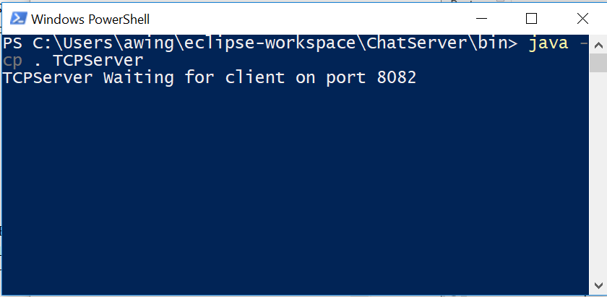

* + Start JMeter
  + Create a test plan with a test group
  + Use the TCP Sampler – localhost and port 8082
  + Add a “Results Tree” Listener
  + Add a “Response Time Graph” listener
    - Set the Interval to 1000 ms.
  + Run the test with 150 users.
    - Observe the results
    - On the results tree look at the three tabs
    - Observe the graph closely
  + Run the test with 3000 users.
    - Observe the results again.
    - View the output of the metrics closely
  + Run the tests again with a different load.
    - Observe the results
  + And again
    - …
  + …
* Make sure you clear your listeners between each run.

Add screen captures for the following.

1. The “TCP Sampler” page
2. The “Results Tree” page with one result selected showing the sampler result page
3. The “Response Time Graph” page showing the graph in the graph tab
4. The command window or powershell window with the running TCPServer output

You must submit this document to the “assignment 8” drop box.

Do not zip anything.

## Marking Scheme:

|  |  |  |
| --- | --- | --- |
| **Marks Available** | **What Are the Marks Awarded For?** | **Marks Awarded** |
|  | | |
| **20** | **A successful test** |  |
| **20** | **All screenshot collected and are correct** |  |
| **10** | **Followed all instructions to the letter** |  |
| **___ 50** | **TOTAL MARKS** |  |

